SETTING HEALTHY BOUNDARIES AS A RELATIVE PROVIDER

When you’re driving down the road, street signs and road markers can help you know if you’re on the right track, while creating boundaries that allow traffic to move efficiently and safely. When you’re dealing with people, however, it can be a little bit harder to set up those boundaries — though it’s just as important for ensuring the health and well-being of yourself and the people you care about.
Setting realistic and healthy boundaries is particularly important for family caregivers, who are often put in a position where they need to be all things to the loved one in their care. On any given day, a caregiver may be a driver, a chef, a hairdresser, and a housekeeper. It can be hard to set limits and take a step back from providing this level of care.
As a result, many family caregivers end up suffering from severe stress and burnout, which can take a toll on their health and relationships. On top of this, many family caregivers say that they regularly have trouble sleeping, put off doctor’s appointments, and skip exercise and healthy meals.
Caregiving is a profound and noble act of love — but it’s hard to deny that caring for another person can sometimes feel overwhelming.
When managing the daily routines and responsibilities of caregiving starts to feel like too much, it may be time to take a step back and draw up new personal boundaries. Setting down reasonable limits for yourself and your loved one can help make things easier for everyone — giving you back time and energy, while helping to build a new foundation of honesty and actually strengthening your relationships with your loved ones over time.
So, what goes into setting healthy, productive, and useful boundaries with your loved ones? Family caregivers can make a change by…

Learning How to Say “No”
Learning when and how to say no is one of the most important things a family caregiver can do to set healthy, sustainable boundaries with their loved ones and the rest of their caregiving team — but it can also be a difficult step to take.
As Deborah Colgan, MA, M.Ed., NCC, writes for Today’s Caregiver:
“Saying ‘no’ may seem like a harsh statement to a caregiver who prides herself on being a helpful, kind and loving person. In fact, most caregivers choose to become one because they feel a moral imperative to do so. This imperative may come from a number of sources including family relationships and roles, friendship ties and social expectations.”
However, as she notes, “No” doesn’t necessarily “have to have a negative connotation attached to its meaning.” A “no” may mean…
- “I’m tired and don’t feel capable of doing the task.”
- “I’m not living up to my personal expectations for myself.”
- “It’s time for things to change.”
- “I need a break for rest and reflection.”
All of these feelings are totally valid and totally natural, and allowing yourself to feel them can be healthy and productive. As Ms. Colgan puts it, setting these boundaries can help “remind the caregiver and family member that their relationship is between two adults,” and that there needs to be “expectations of mutual respect and autonomy for the relationship to be successful.”

Managing Feelings of Guilt
Guilt and shame are two powerful emotions, and they’re two emotions that commonly come up for family caregivers. Learning how to deal with these feelings in a healthy way can help you approach caregiving with new eyes, so that you can be your best for your loved one — and learn to respond more effectively in those moments when you may fall a little bit short of your own expectations.
One way to start thinking about guilt in a new way may be to address your “shoulds.” Here’s how aging services expert Anne Tumlinson puts it on her Daughterhood blog:
“Just because someone asks you to do something doesn’t mean you should do it. This may seem obvious on the surface but you’d be surprised how many of us behave as if we must respond to every demand with an outpouring of our time and energy. I’ve noticed my own tendency to turn requests into objects of resentment because I immediately assume each one is a ‘should do.’”
The same also goes for the “asks” we make of ourselves! As Tumlinson explains, many caregivers set personal expectations about what they should be doing at any given time, and how they should be doing it. She recommends instead framing things in terms of what you can do. Be comfortable with what you’re capable of, try to delegate or find solutions for what you can’t, and recognize that it may not be realistic to get everything done at once. Remember that “your being is more important than your doing:”
“Nothing you do – whether good, bad, or great – can change the fundamental awesomeness of who you are.”

Setting Realistic Limits, Internally and Externally
A key part of learning when to say “no” ultimately comes down to setting and recognizing your limits. This includes the “internal” limits that you must set for yourself, and the “external” boundaries that you’d like to keep up with the people in your life, including your loved one and the other members of your family, as well as healthcare providers and professional caregivers.
One way to think of this may be to set your “non-negotiables,” as the Working Daughter blog explains:
“Boundaries protect things. So you can’t set boundaries if you don’t know what it is you are protecting. Maybe it’s your health, or your career, or time for other family. Maybe it’s visiting your parent at the nursing home daily. Your non-negotiable list is what you say yes to. Anything that interferes with that list is a clear and simple no.”
As an example? If self care is incredibly important to you, and caregiving is keeping you from taking care of yourself , it may be time to reassess your arrangement and consider getting additional help.
Similarly, if you find that providing intimate care for your loved one — such as help with bathing, grooming, and dressing — is putting a strain on your relationship, it may be time to refocus on the caregiving tasks you feel more comfortable with, and find help for the rest.
Internally, this may take some getting used to. It’s important to remember that reaching out for help is a generous and strong thing to do, and that setting limits doesn’t make you any less of a wonderful caregiver. In fact, it’s a meaningful way to keep making sure that your loved one is receiving the full amount of care and support that they deserve. Give yourself grace, and remember that you also deserve care, rest, and the chance to breathe. Make time for yourself and find ways to practice self-care, however and whenever you can.

Making Communication Easier
Putting plans and boundaries into place will often require a good deal of communication. It can be hard to broach difficult topics with your loved one, especially if you’re worried about hurting their feelings or putting a new dimension onto your relationship.
As Colgan puts it for Today’s Caregiver, in order to successfully establish boundaries, “the caregiver needs to develop communication tools to express” their needs. She encourages caregivers to try to speak from an “I” point of view, “expressing the caregiver’s limitations or feelings and offering an alternate solution.”
As an example, let’s say that you are worried about your loved one suffering a fall, but cannot always be present to help them up and down the stairs. Expressing your need in this situation may look like something like this:
“ I cannot always be here to help you walk up the stairs out front. I am worried about your safety and mine, and I believe we need to build a ramp to make it easier for you to be independent and access your home when I’m not around.”
If you’re concerned about saying “no” to a request or an obligation, try to prepare a follow-up offer, stating what you can do instead. Plan ahead, and practice declining requests in a kind, calm, and helpful way.
When you need to have a larger personal conversation about your role as a caregiver, remember to carve out plenty of time; bring in an outside voice that your loved one respects, if needed; respond to their ideas with empathy and compassion; and try to hold these talks as early as possible, in a calm and open environment.

Getting Support When You Need It
Finally, remember that you don’t have to go through the ups and downs of caregiving alone. If you need time back to focus on other things, or a helping hand that can let you reset your boundaries with your loved one, there are lots of resources out there that can help make life easier.
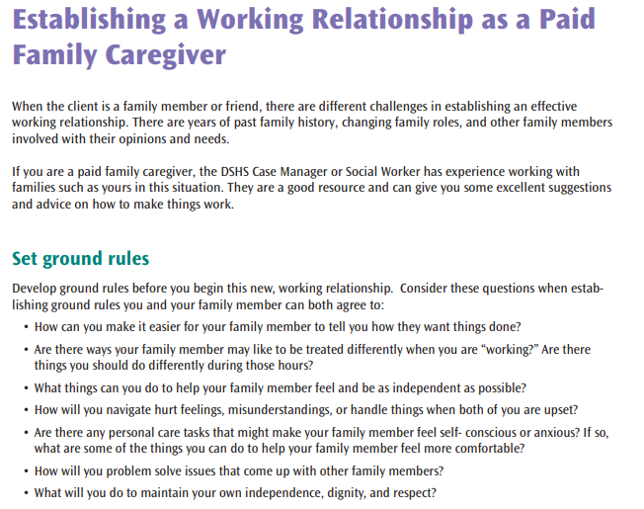
For yourself, you may wish to look into caregiver support groups in your area and the NWKS family Facebook group. These groups can help you connect with other people who are in your situation, and who can provide guidance and support.

